

TMF1014 INTRODUCTION TO PROGRAMMING
REPORT

INTRODUCTION TO PROGRAMMING PROJECT

GROUP LECTURE: GROUP 1

LECTURER’S NAME: SIR MOHAMAD JOHAN BIN AHMAD KHIRI

GROUP MEMBERS:
No. | Name | Matric No.
1. | MOHAMMAD HAMKA IZZUDDIN BIN MOHAMAD YAHYA | 73571
2. | FAIZATUL FITRI BIN BOESTAMAM | 73449
3. | HARITH ZAKWAN BIN ZAKARIA | 73484
4. | IMAN TARMIZI ROSALINA | 73496

TABLE OF CONTENT

page
1.0 INTRODUCTION 3
1)Expected Theory/Concept 3
2) Related topics 4
2.0 USER MANUAL 5
1) Flowchart 5
2) Pseudocode 6
3) User manual 17
3.0 PRINT SCREENS 23

1.0 INTRODUCTION

1)Expected Theory/Concept

A console program is a program designed to be used via a text-only computer interface. It can be a text terminal, command line interface, or the text-based interface of some operating systems. A user typically interacts with a console application using only a keyboard and display screen. Many console applications such as command line interpreters are command line tools. Via modular programming, console programmes can be programmed and developed to easily build consoles using functions and using suitable data types to handle data for programmes such as arrays, structures and files. We can also incorporate the use of pointer, formatted inputs and outputs and other techniques to ensure that code and performance are well coordinated.

Therefore, we have been given an assignment which is to design and develop a console program that receives inputs from user and display correct outputs and to simulate The Korean Food (TKF) restaurant payment.

In this console program, we apply some basic knowledge that we have learn which is the function, array, structures and file processing. Why do we need to apply this knowledge in developing this console program? This is because this 4 basic programming can help us to build the console program effectively. For instance, functions is a declaration block that executes a particular purpose and by applying the function we can modularize the console program. Beside, array is a programming framework that generalises scalar operations to be extended transparently to higher-dimensional arrays, and a data type is used in other word arrays to store several values under a single name in the same data type. Another way to store data such as arrays is data structures, but variables with various kinds of data can be stored. Moreover, the file is a byte array that is stored on disk-like secondary storage devices. File processing in C programming helps us, through our C programming, to build, edit, read and erase the files stored on the local file system.

In this console program, we display a list of menus of The Korean Food (TKF) restaurant which consist of 5 menus which is Bibimbap, 2 pieces of Korean fried chicken, Bulgogi, Japchae and Haemul Pajeon and the price vary for each of the menu starting from RM 7.00 for Haemul Pajeon, RM 8.50 for Japchae and Bulgogi, RM 9.00 for 2 pieces of Korean fried chicken, and RM 10.00 for Bibimbap. This price is only valid for the regular size and in this program we also provide a large size of menus which the price are slightly higher than the regular price. However, this price is only for the non-member where as for the member would see about 10% discount off for regular size and 15 % discount off for large size. In addition, we also have two user options in the front view, the first option for placing an order and the second option for a transaction log. If the user selects the first alternative, then they will be asked if they are members or not and whether they want to dine-in or take away, the answer for these two options is either yes or no and dine-in or take away and if they chose other than this option, the program will show an 'invalid' output to indicate that they have entered the incorrect input and the program will iter endlessly until the user enter correct input. For the second option which is the transaction record, it can not be displayed as long as the user has not recorded their data in the first option. After that, they will be asked to select one of the 5 menus and the size of the food to be ordered must also be selected. If they enter the incorrect data, the same thing occurs, it will reveal a 'invalid' output and repeat before the right input is entered. After that, in order to show the chart, it will show the order cart. A note showing how many more orders should be placed can also be shown. In addition, three choices are now displayed: the first option is to add additional menus, the second option is to delete the previous option from the order cart, and the third option is to continue to checkout. If the user chooses the first option, then the programme repeats the same question as member, dine-in or take away, menu, and menu size before the order quota runs out, and after the user has run out of the order quota, the programme will automatically proceed with checkout. At the checkout, it will display the user receipt, total order and customer counter. then the program will ask if the user wants to extend or not. If they choose no then the program will continue to stop immediately but if they choose yes then the program will display the homepage and this time only the user can access the second option in the main option because they have successfully entered the data into the program record.

2) Related topics
- Function
- Array
- Basic Data Structures
- File Operations

2.0 USER MANUAL

1) Flowchart

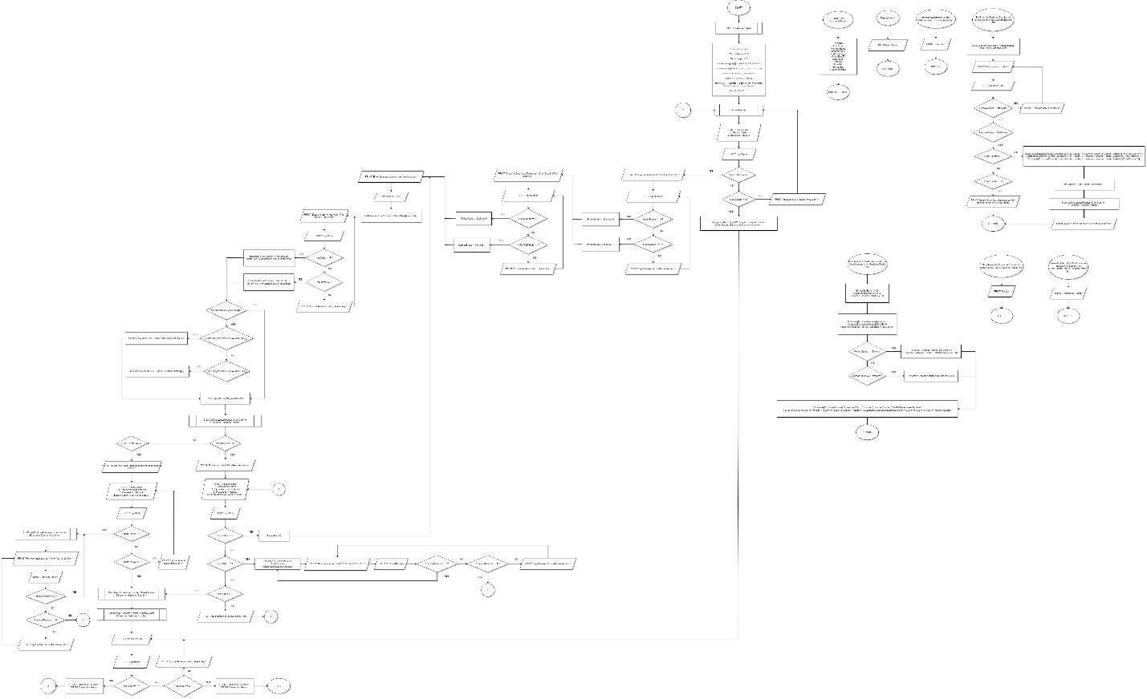

2) Pseudocode

START
SET CustomerCounter = 0
SET DiscountRegular = 0.10
SET DiscountLarge = 0.15
SET NonMemberRegular[5] = 10.00, 9.00, 8.50, 8.50, 7.00
SET NonMemberLarge[5] = 15.00, 14.00, 13.50, 13.50, 12.00
SET Member[2] = "Member", "Non Member"
SET Method[2] = "Dine-In", "Takeaway"
SET MenuName[5] = "Bibimbap", "2 pc(s) Korean Fried Chicken", "Bulgogi", "Japchae", "Hameul Pajeon"
SET MenuSize[2] = "R", "L"

SET STRUCTURE CustomerDetails
RecieptNo
TotalOrder
MemberStatus
MethodStatus
OrderName
OrderSize
OrderBill
TotalBill
FinalBill
ServiceTax
GovernmentTax
END STRUCTURE
DO
FUNCTION CALL DisplayMenu
PRINT Menu Table
END FUNCTION
PRINT Tax Chargers Details
PRINT” Please Select: “
PRINT “1. Make an Order “
PRINT “2. Transaction Records”
DO
PRINT “Enter the option you want to select:”
INPUT InputOption
IF (InputOption != 1 AND InputOption != 2)
PRINT “Input entered is invalid, please retry”
END IF
WHILE (InputOption != 1 AND InputOption != 2)
END DO-WHILE
IF (InputOption == 1)
ASSIGN Customer[CustomerCounter].ReceiptNo = CustomerCounter
DO
PRINT "Are you a member? (Y for Yes | N for No): "
INPUT InputMember
IF (InputMember == 'Y')
ASSIGN Customer MemberStatus = Member
ELSE IF (InputMember == 'N')
ASSIGN Customer MemberStatus = Non-Member
ELSE
PRINT “Input entered is invalid, please retry”
END IF ELSE IF
WHILE (InputMember != 'Y' AND InputMember) != 'N')
END DO-WHILE
DO
PRINT "Order for Dine-In or Takeaway? (D for Dine-In | T for Takeaway): "
INPUT InputMethod
IF (InputMethod == 'D')
ASSIGN Customer MethodStatus = Dine-In
ELSE IF (InputMethod == 'T')
ASSIGN Customer MethodStatus = Takeaway
ELSE
PRINT “Input entered is invalid, please retry.”
END IF
WHILE (InputMethod != 'D' AND InputMethod != 'T')
END DO WHILE
FOR (OrderCounter = 0; OrderCounter < 5; OrderCounter++)
SET Customer Total Order = 0
DO
SET InputOrder = 0
PRINT “Enter the menu number you want to order:”
INPUT InputOrder
IF (InputOrder != 1 AND InputOrder != 2 AND InputOrder != 3 AND InputOrder != 4 AND InputOrder != 5)
PRINT “Invalid”
END IF
WHILE (InputOrder != 1 AND InputOrder != 2 AND InputOrder != 3 AND InputOrder != 4 AND InputOrder != 5)
ASSIGN OrderName[OrderCounter] = MenuName[InputOrder]
END DO WHILE
DO
PRINT “Enter the size for the order (R for Regular | L for Large):”
INPUT InputSize
IF (InputSize == 'R')
ASSIGN Customer Order Size = Regular
CALCULATE MenuPrice = NonMemberRegular[InputOrder]
ELSE IF (InputSize == 'L')
ASSIGN Customer Order Size = Large
CALCULATE MenuPrice = NonMemberLarge[InputOrder]
ELSE
PRINT “Input entered is invalid, please retry.”
END IF ELSE IF
WHILE (InputSize != 'R' AND InputSize != 'L')
END DO-WHILE
IF Customer Member Status = Member
IF Customer Order Size = Regular
CALCULATE MenuPrice = MenuPrice - (MenuPrice*DiscountRegular)
ELSE IF Customer Order Size = Large
CALCULATE MenuPrice = MenuPrice - (MenuPrice*DiscountLarge)
END IF ELSE IF
END IF
ASSIGN Customer OrderBill[OrderCounter] = MenuPrice
FUNCTION CALL OrderCart
PRINT Order Cart
END FUNCTION
DO
SET ContinueEdit = 0
IF (OrderCounter < 5)
PRINT “Notice: You have __ order(s) remaining.”
SET InputEdit = 0
DO
PRINT “Please Select:”
PRINT “1. Add another order”
PRINT “2. Remove existing order”
PRINT “3. Proceed to checkout”
PRINT “Enter the option you want to select:”
INPUT InputEdit
IF (InputEdit != 1 AND InputEdit != 2 AND InputEdit != 3)
PRINT “Input entered is invalid, please retry.”
END IF
WHILE (InputEdit != 1 AND InputEdit != 2 AND InputEdit != 3)
END WHILE
IF (InputEdit == 1)
FUNCTION CALL DisplayMenu
PRINT Menu Table
END FUNCTION
ELSE IF (InputEdit == 2)
DO
FUNCTION CALL EditOrder
SET TotalOrder = OrderCounter+1
SET OrderCounterPlaceholder = OrderCounter
IF (TotalOrder != 0)
DO
PRINT “Remove which order? (Y for Yes | N for No):”
INPUT RemoveOrder
IF (RemoveOrder > TotalOrder)
PRINT “There are only __ order(s).”
END IF
WHILE (RemoveOrder > TotalOrder)
END DO-WHILE
IF (RemoveOrder <= TotalOrder)
IF (OrderCounter > 0)
FOR (OrderCounter = RemoveOrder-1; OrderCounter < TotalOrder; OrderCounter++)
ASSIGN Customer[OrderName[OrderCounter] = Customer[CustomerCounter].OrderName[OrderCounter+1]
ASSIGN Customer[CustomerCounter].OrderSize[OrderCounter] = Customer[CustomerCounter].OrderSize[OrderCounter+1]
ASSIGN Customer[CustomerCounter].OrderBill[OrderCounter] = Customer[CustomerCounter].OrderBill[OrderCounter+1]
END FOR
ASSIGN Total Order = OrderCounterPlaceholder-1
FUNCTION CALL OrderCart
PRINT Order Cart
END FUNCTION
PRINT “Notice: Order has been successfully removed.”
ELSE IF (OrderCounter == 0)
PRINT “Notice: Order has been successfully removed, order cart is now empty.”
END IF ELSE IF
END IF
END IF
END FUNCTION
IF (OrderCounter > 0)
SET OrderCounter = OrderCounter - 1
DO
PRINT “Remove another order? (Y for Yes | N for No):”
INPUT ContinueRemove
IF (ContinueRemove == 'N')
ASSIGN ContinueEdit = 1
ELSE IF (ContinueRemove != 'Y' AND ContinueRemove != 'N')
PRINT “Input entered is invalid, please retry.”
END IF ELSE IF
WHILE (ContinueRemove != 'Y' AND ContinueRemove != 'N')
END DO-WHILE
ELSE IF (OrderCounter == 0)
ASSIGN OrderCounter = -1
ASSIGN ContinueRemove = ‘b’
WHILE (ContinueRemove == 'Y')
END DO WHILE
ELSE IF (InputEdit == 3)
ASSIGN OrderCounter = OrderCounter+6
ASSIGN Customer Total Order = OrderCounter
ELSE IF (OrderCounter == 4)
PRINT “Notice: You have reached the maximum amounts of orders.”
SET InputEdit = 0
DO
PRINT “Please Select:”
PRINT “1. Removing existing order”
PRINT “2. Proceed to checkout.”
PRINT “Enter the option you want to select:”
INPUT InputEdit
IF (InputEdit != 1 AND InputEdit != 2)
PRINT “Input entered is invalid, please retry.”
END IF
WHILE (InputEdit != 1 AND InputEdit != 2)
END DO-WHILE
IF (InputEdit == 1)
DO
FUNCTION CALL EditOrder
SET TotalOrder = OrderCounter+1
IF (TotalOrder != 0)
DO
PRINT “Remove which order?”
INPUT RemoveOrder
IF (RemoveOrder > TotalOrder)
PRINT “There are only __ order(s).”
END IF
WHILE (RemoveOrder > TotalOrder)
END DO-WHILE
IF (RemoveOrder <= TotalOrder)
IF (OrderCounter > 0)
FOR (OrderCounter = RemoveOrder-1; OrderCounter < TotalOrder; OrderCounter++)
ASSIGN Customer[CustomerCounter].OrderName[OrderCounter] = Customer[CustomerCounter].OrderName[OrderCounter+1];
ASSIGN Customer[CustomerCounter].OrderSize[OrderCounter] = Customer[CustomerCounter].OrderSize[OrderCounter+1];
ASSIGN Customer[CustomerCounter].OrderBill[OrderCounter] = Customer[CustomerCounter].OrderBill[OrderCounter+1];
END FOR
ASSIGN OrderCounter = OrderCounterPlaceholder-1
FUNCTION CALL OrderCart
PRINT Order Cart
END FUNCTION
PRINT “Notice: Order has been successfully removed.”
ELSE IF (OrderCounter == 0)
PRINT “Notice: Order has been successfully removed, order cart is now empty.”
END IF ELSE IF
END IF
END IF
END FUNCTION
IF (OrderCounter > 0)
CALCULATE OrderCounter = OrderCounter - 1
DO
PRINT “Remove another order? (Y for Yes | N for No):”
INPUT ContinueRemove
IF (ContinueRemove == 'N')
SET ContinueEdit = 1
ELSE IF (ContinueRemove != 'Y' AND ContinueRemove != 'N')
PRINT “Input entered is invalid, please retry.
END IF ELSE IF
WHILE (ContinueRemove != 'Y' AND ContinueRemove != 'N')
END DO-WHILE
ELSE IF (OrderCounter == 0)
ASSIGN OrderCounter = -1
ASSIGN ContinueRemove = 'b'
END IF ELSE IF
WHILE (ContinueRemove == 'Y')
END DO-WHILE
ELSE IF (InputEdit == 2)
ASSIGN Customer Total Order = OrderCounter+1
END IF ELSE IF
WHILE (ContinueEdit == 1)
END DO-WHILE
IF (Customer TotalOrder > 5)
ASSIGN Customer TotalOrder = Customer TotalOrder-5
END IF 318
END FOR
FUNCTION CALL CalculateBill
SET ServiceTaxRate = 0.10
SET GovernmentTaxRate = 0.06
SET Customer TotalBill = 0.00
FOR (OrderCounter = 0; OrderCounter < Customer TotalOrder; OrderCounter++)
CALCULATE Customer TotalBill = Customer TotalBill + Customer OrderBill
END FOR
IF (Customer MethodStatus == "Dine-In")
CALCULATE Customer ServiceTax = Customer TotalBill * ServiceTaxRate
ELSE IF (Customer MethodStatus == "Takeaway")
ASSIGN Customer ServiceTax = 0.00
END IF ELSE IF
CALCULATE Customer GovernmentTax = Customer TotalBill * GovernmentTaxRate
CALCULATE Customer FinalBill = Customer TotalBill + Customer ServiceTax + Customer GovernmentTax
END FUNCTION
FUNCTION CALL FinalReceipt
PRINT Customer Final Receipt
END FUNCTION
ELSE IF (InputOption == 2)
FUNCTION CALL TransactionRecord
IF (CustomerCounter == 0)
PRINT “No orders have been made yet.”
ELSE
PRINT Transaction Record
END IF
END FUNCTION
END IF ELSE IF
DO
PRINT “Continue? Y/N”
INPUT Continue
IF (Continue != 'Y' AND Continue != 'N')
PRINT “Input entered is invalid, please retry.”
END IF
WHILE (Continue != 'Y' AND Continue != 'N')
END DO-WHILE
IF (Continue == 'N')
IF (Open and write "TransactionRecord.txt" file) == NULL)
PRINT “File could not be opened.”
ELSE
CREATE File
WRITE Transaction Record
END IF ELSE
END IF
WHILE (Continue == 'Y')
END DO-WHILE
END

3) User manual

- Open the source code
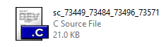

- Execute compile and run

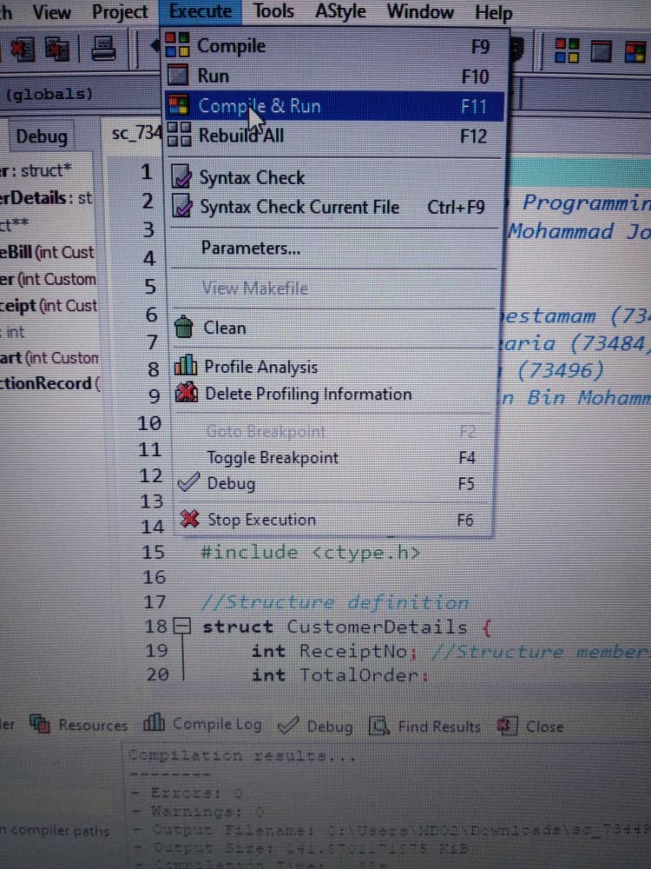

- Please choose the Option 1 on the front view. It is advisable for the customer to first select option 1, so they can access option 2 to verify their transaction record after they have made the order.

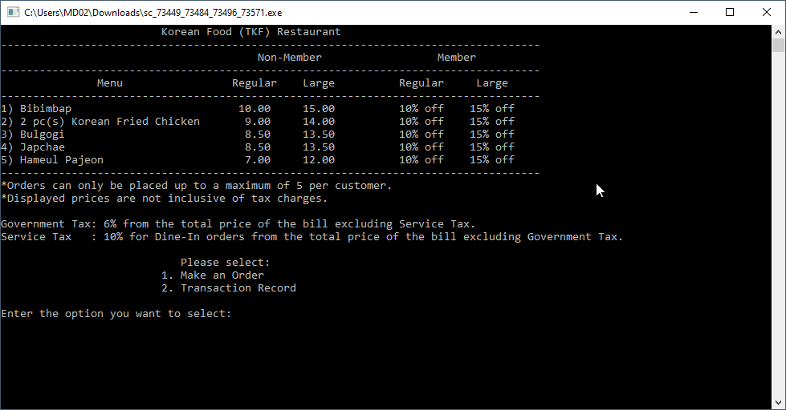

- If you choose the option 1 then the program will ask a few questions that require the user to enter data for member, method, menu and size.
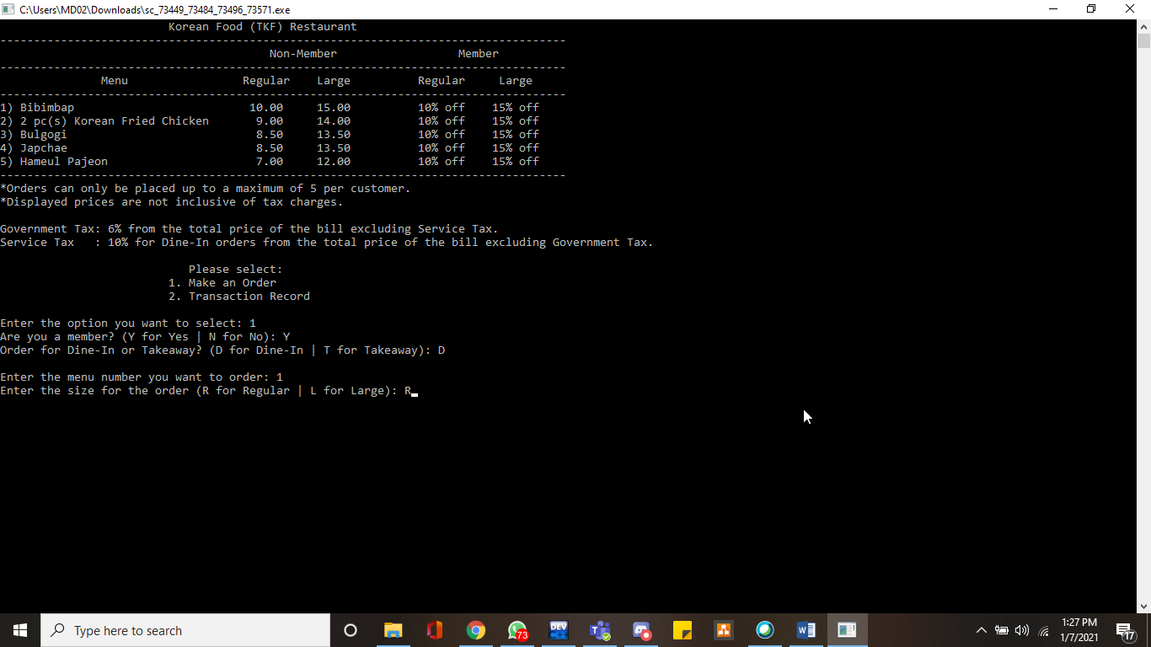

- Data for menu and size will be display after the user entering the data.

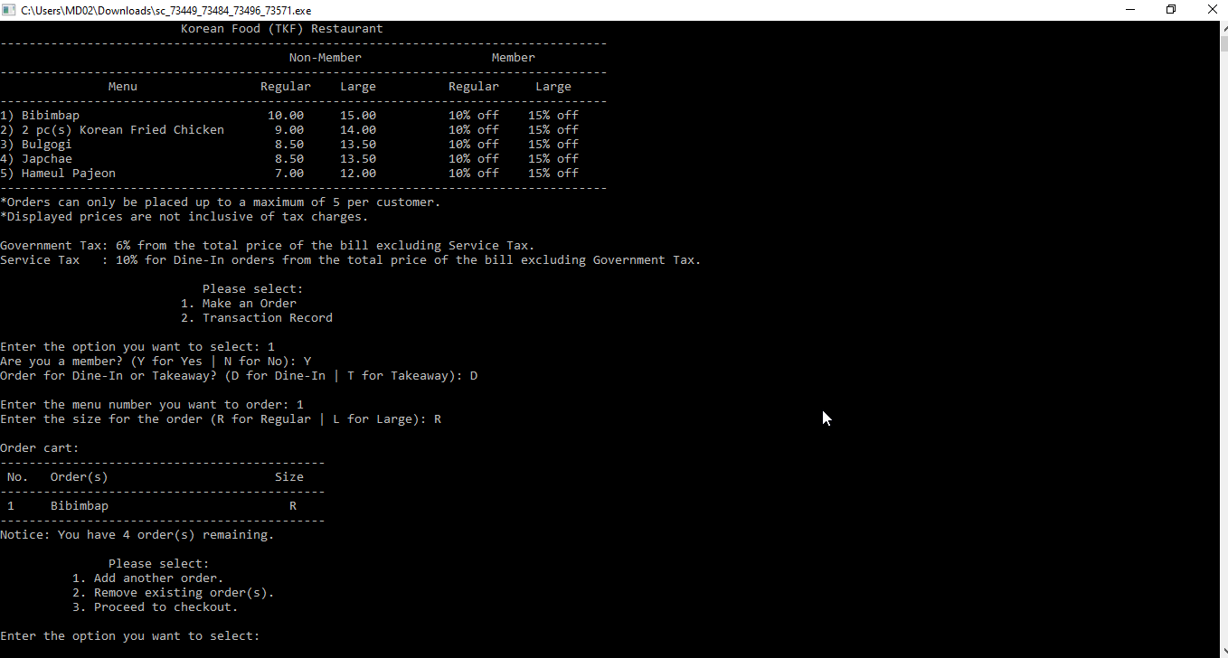

- As soon as an order is placed, you will be given 3 additional choices. Please choose 1st option number if you want to add another order, or if you want to remove your order previous please choose option 2nd but if you want to proceed to checkout please choose the 3rd option.
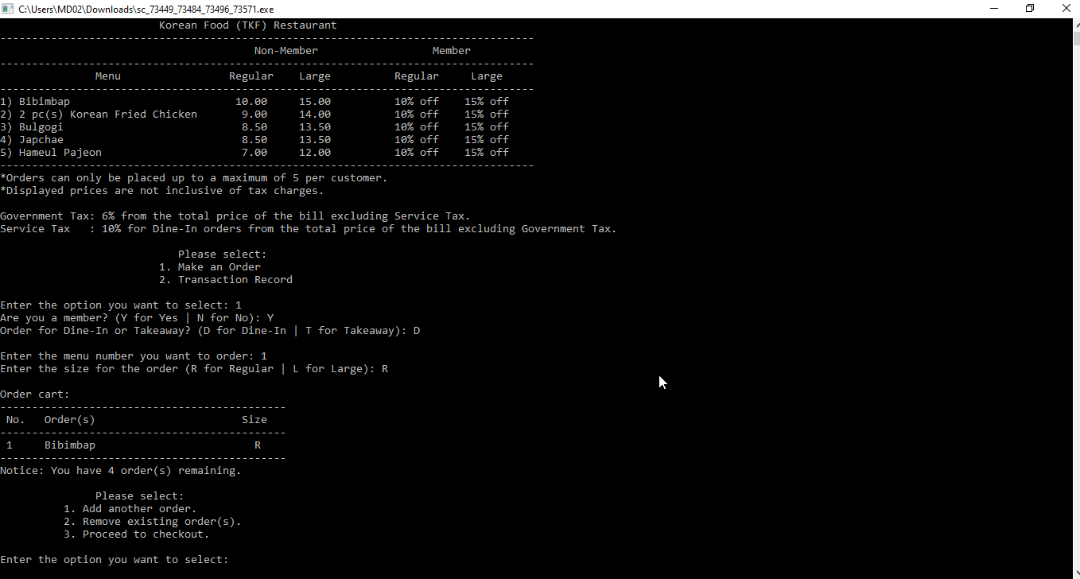

- If you choose the 1st option. It will iterate the menu again and will ask for the user to enter input for menu and size of menu.
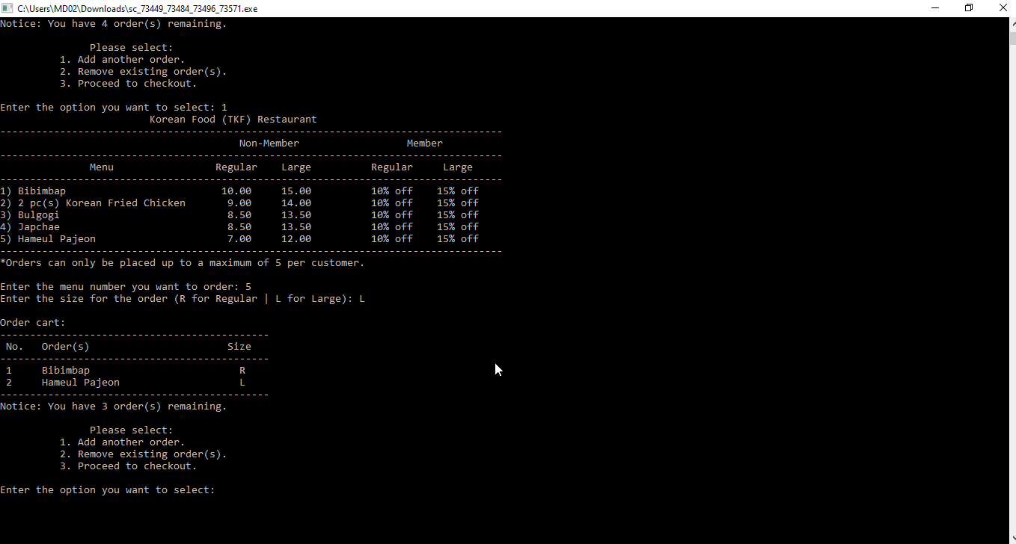

- If you choose the 2nd option. It will display the ordercounter to show the number of order have been made and the program will ask which order the user want to remove and after that it will display the new order cart and will ask the user if they want to remove another order. It will also display the notice to tell the user that program has successfully remove the order and the order quota.
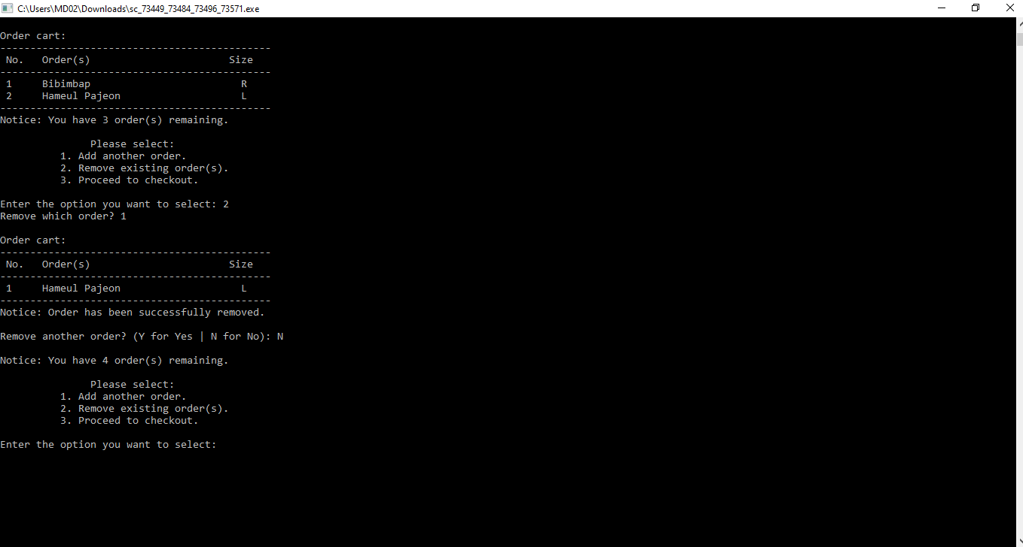

- If you choose the 3rd option, it will automatically show the receipt order for the user and after that it will ask the user wether they want to continue or not. Then after it will ask the user if they want to continue or not, if they choose ‘yes’, then it will redirect the user back to the front view of the program but if the user choose ‘no’ then the program will automatically stop.
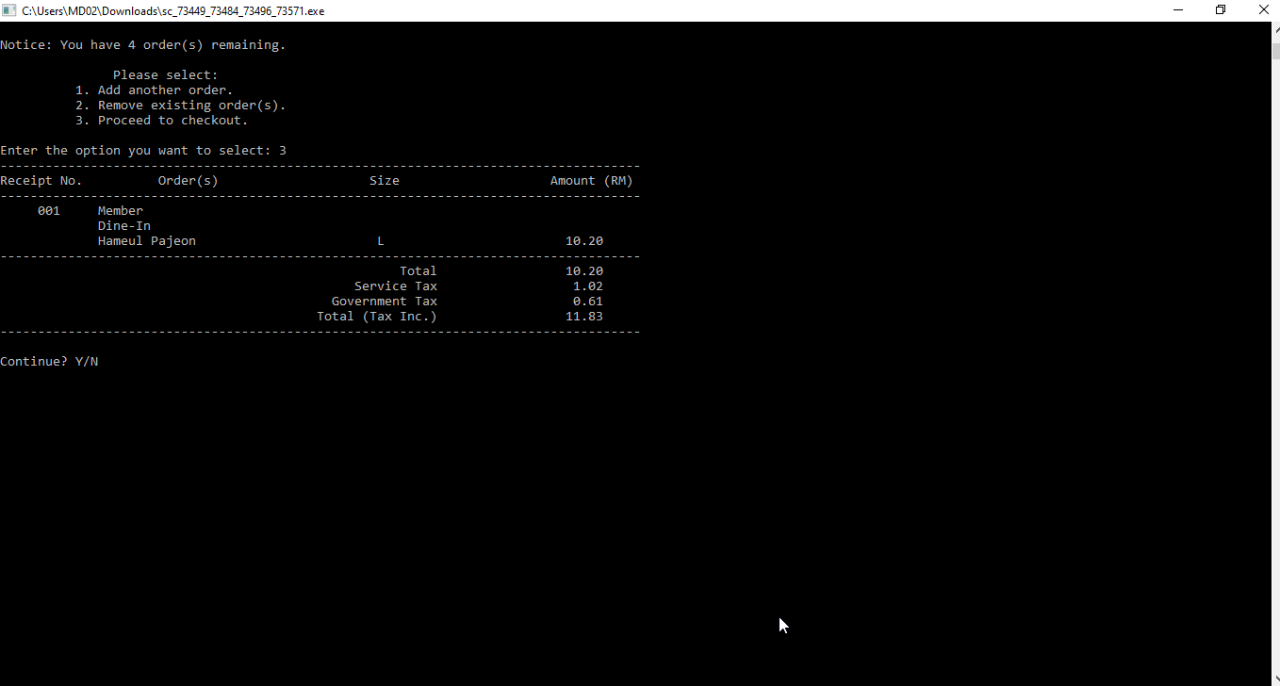

- If you choose ‘yes’, then it will redirect you to the front view of the console program. But if you choose ‘no’ then the program will automatically stop.
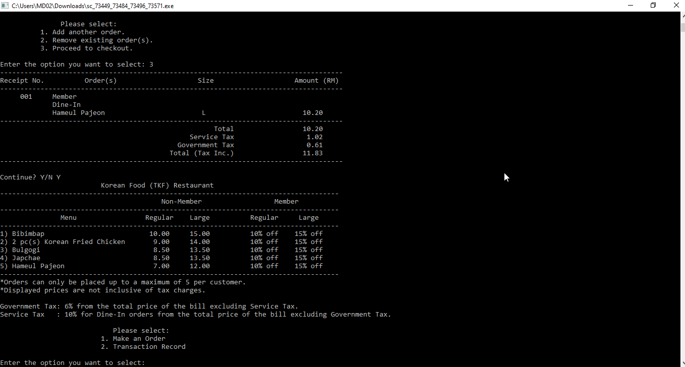

- After you have make your order in the option 1 then you can access the option 2. Then after it will ask the user if they want to continue or not, if they choose ‘yes’, then it will redirect the user back to the front view of the program but if the user choose ‘no’ then the program will automatically stop.
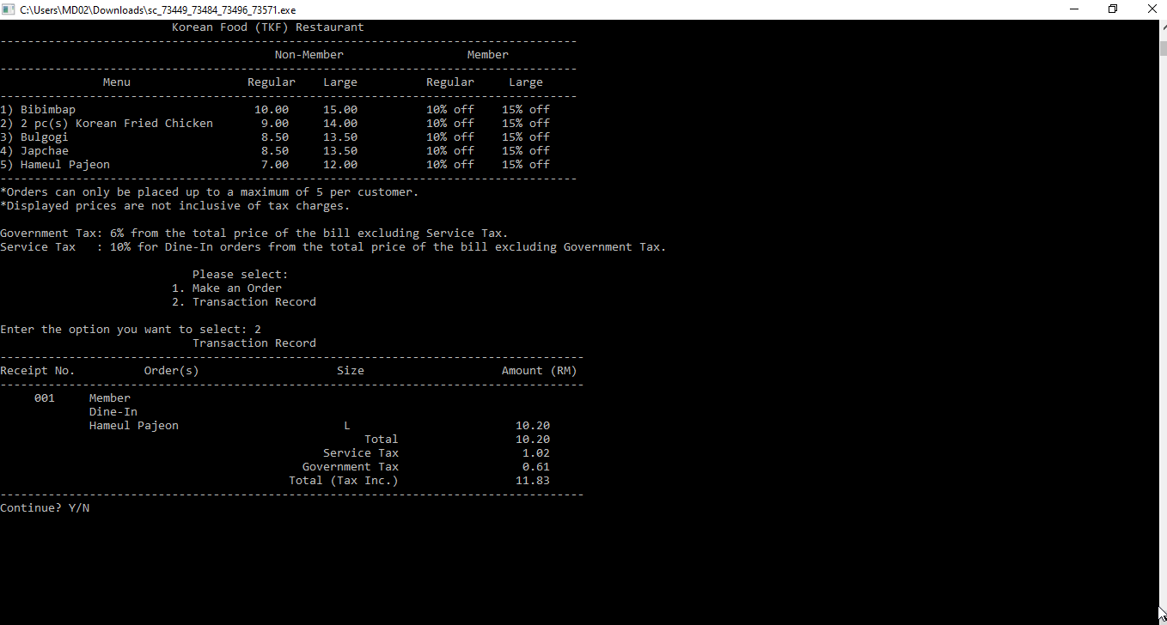

- Repeat from step 3 to 10 to make an order. Then for the step 11 you need to do repeat the step 3 to step 10 first.

3.0 PRINT SCREENS

1) Picture 1 show the front view of the console program which consist of the Korean Food Restaurant with some reminder and the tax charges.
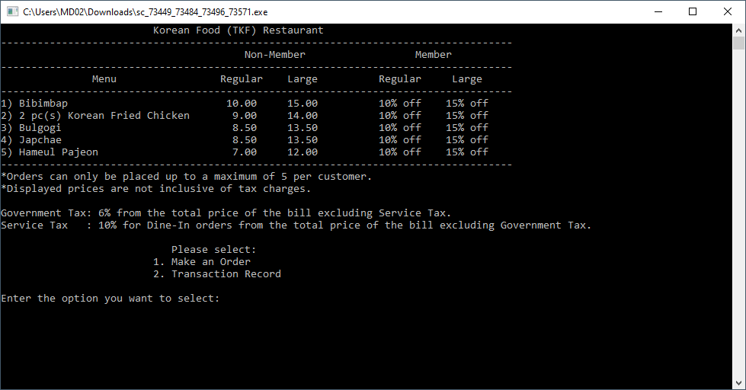
Picture 1

2) Picture 2 show the Option 1 which consist of question member or not, dine-in or take away, menu option, and menu size for the user to enter the data for the console program. It also show the order cart which show the user order and also the notice to show the number of order remaining. After that it display another 3 option for the user to choose. Option cannot be access yet since the user have not enter their data in the program record.
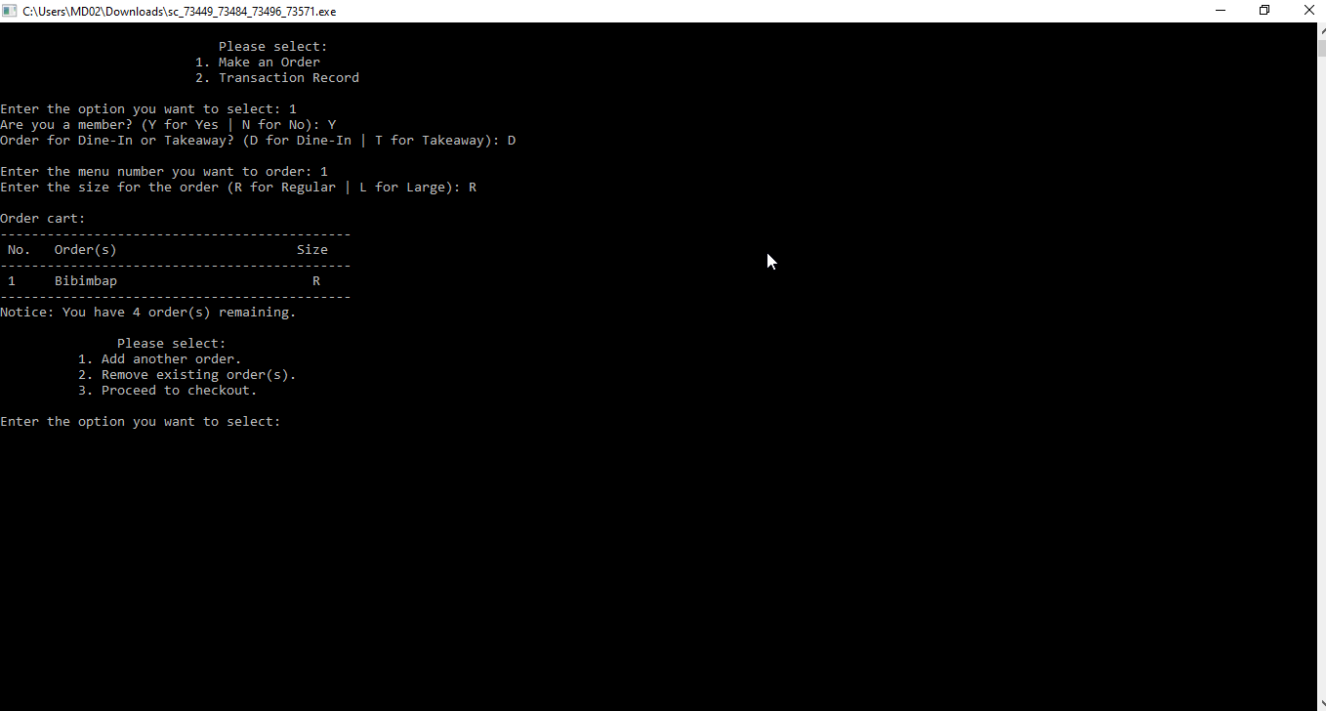
Picture 2

3)Picture 3 show that if the user choose the 1st option then it will repeat the same question before and after that the program will show the order cart and also the notice until the order quota is finish.
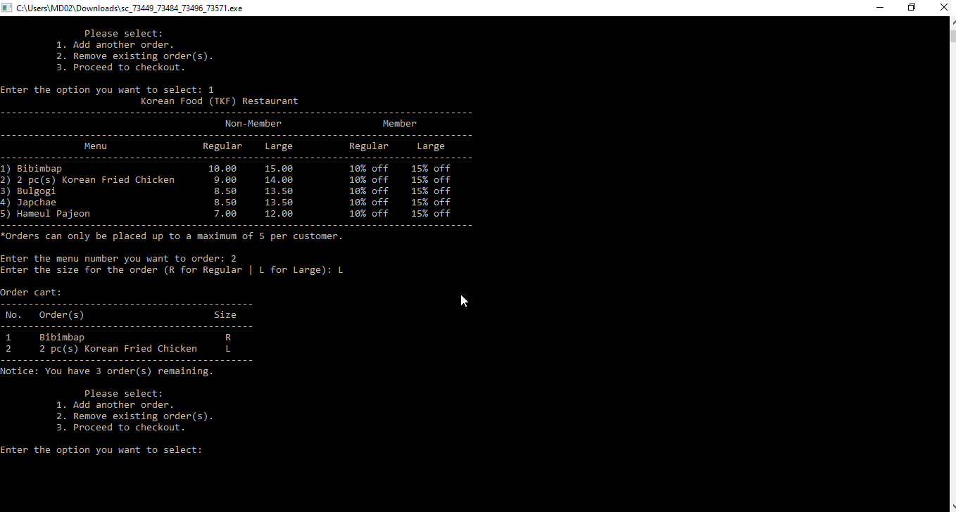
Picture 3

4) Picture 4 indicates that if the user chooses the 2nd choice, the program will ask what order to delete from the order cart, and the user will have to input the number from the order cart. After that, the new order cart will be shown with a note to inform the customer that the order they wish to erase from the program log has been successfully removed. Then it will question whether or not the user wishes to comply with the withdrawal order. Then the same 3 option from option 1 in the front view is seen in picture 5 and also the note to recall the order limit.
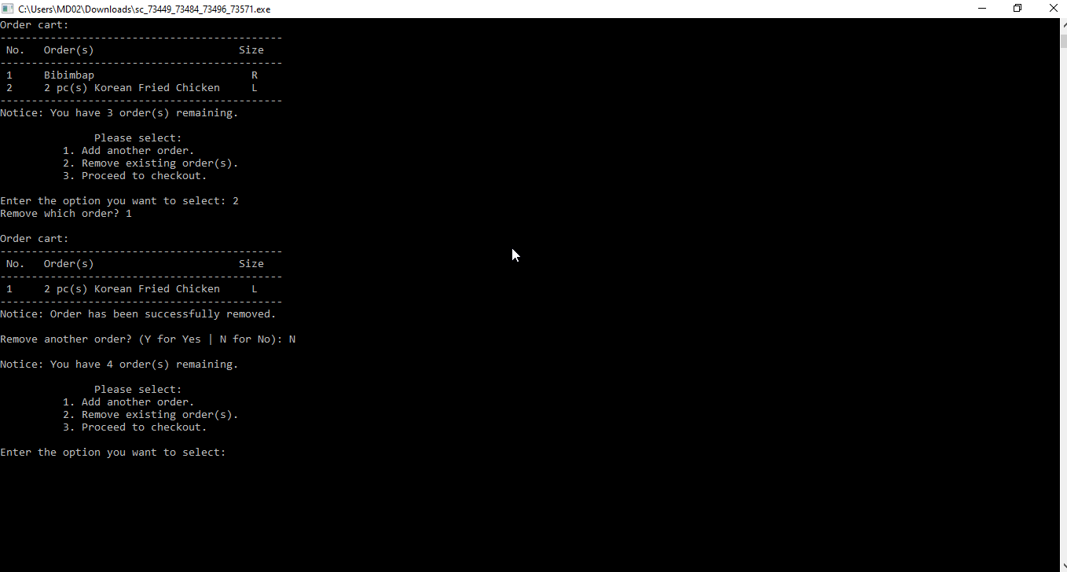
Picture 4
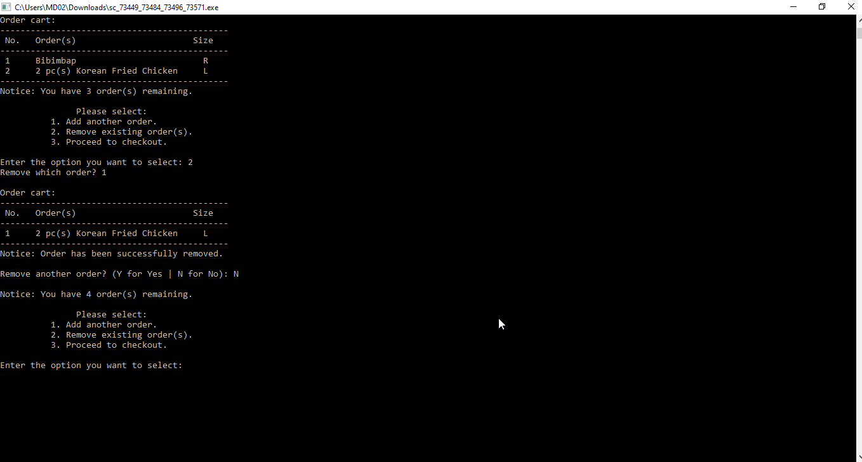
Picture 5

5) Picture 6 show that if the user choose the 3rd option then the program will direct the user to the checkout and will display the order receipt for the user. After that it will ask the user wether they want to continue or not. If they choose no then the program will automatically stop but if they choose yes then the program will redirect them back to the front view.
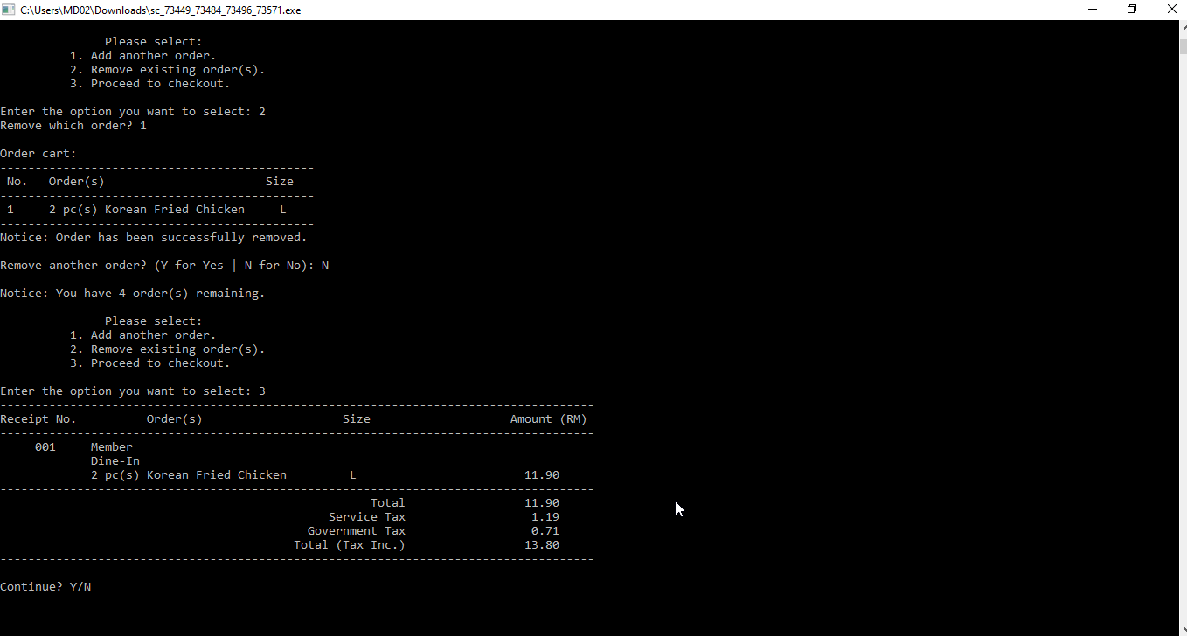
Picture 6

6) Picture 7 show that the program will redirect the user to the front view back and this time the option 2 can be access since user has enter their data in the program record.
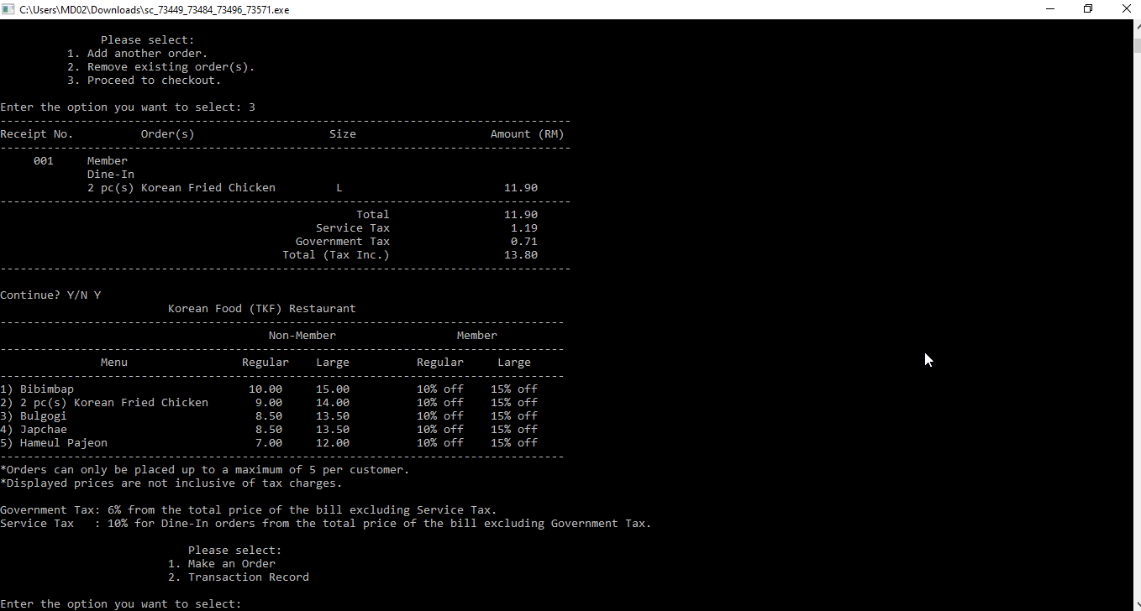
Picture 7

7) Picture 8 show the option 2 of front view which is the transaction record. And it also will ask the user if they want to continue or not. If they choose yes then the program will redirect the user back to the front view but if not the then the program will automatically stop.
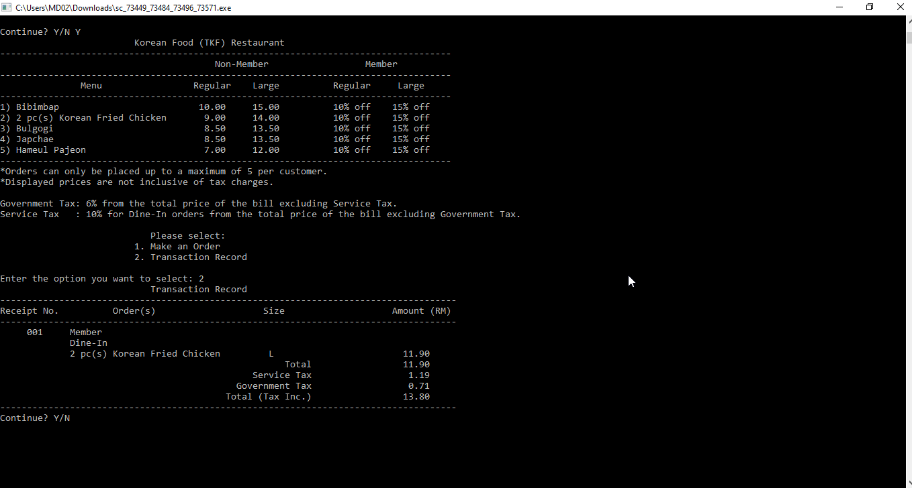
Picture 8

8) Picture 9, 10, 11, 12, 13, 14, and 15 below shows the input validation and error checking.
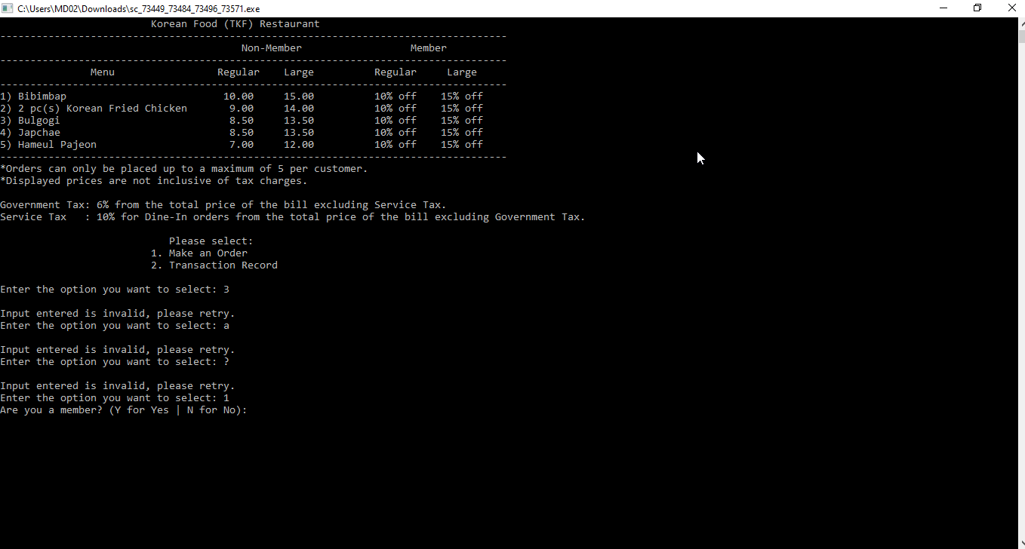
Picture 9
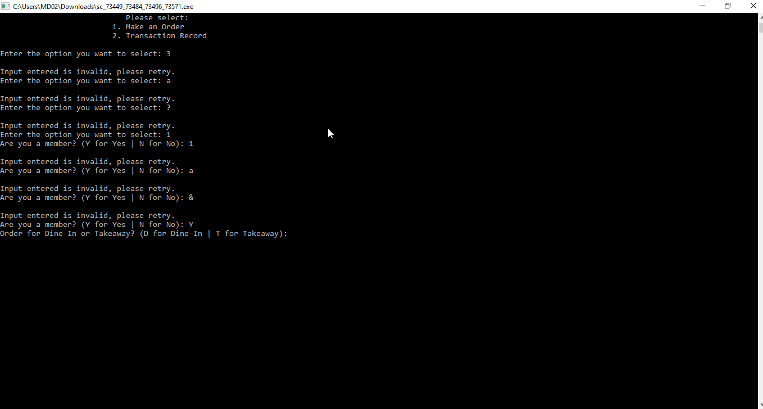
Picture 10
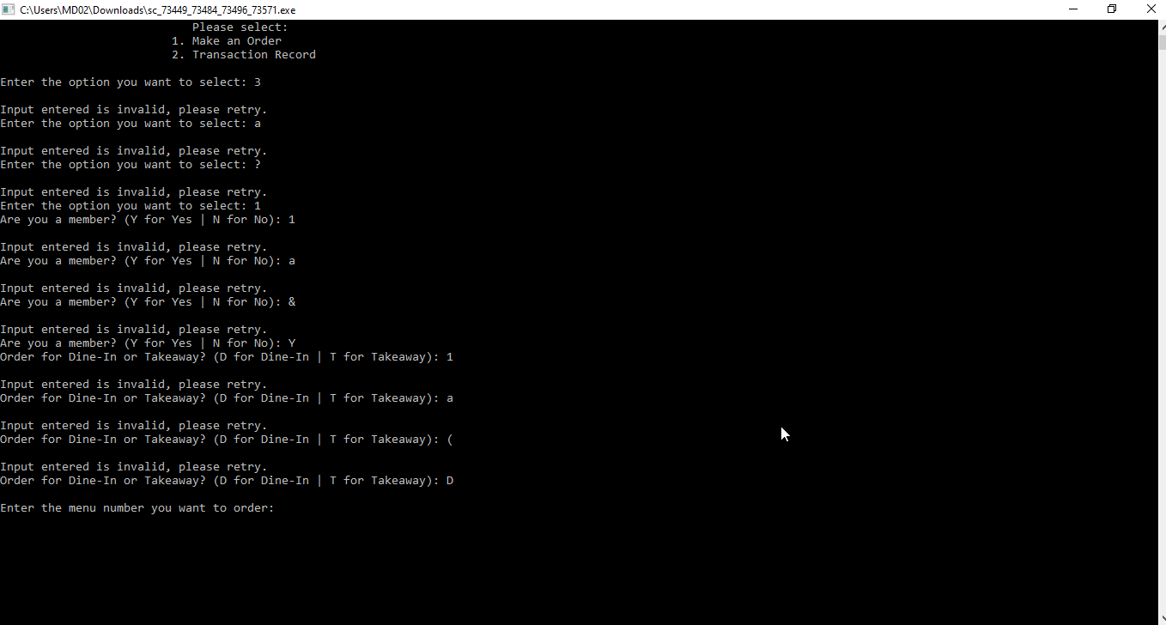
Picture 11

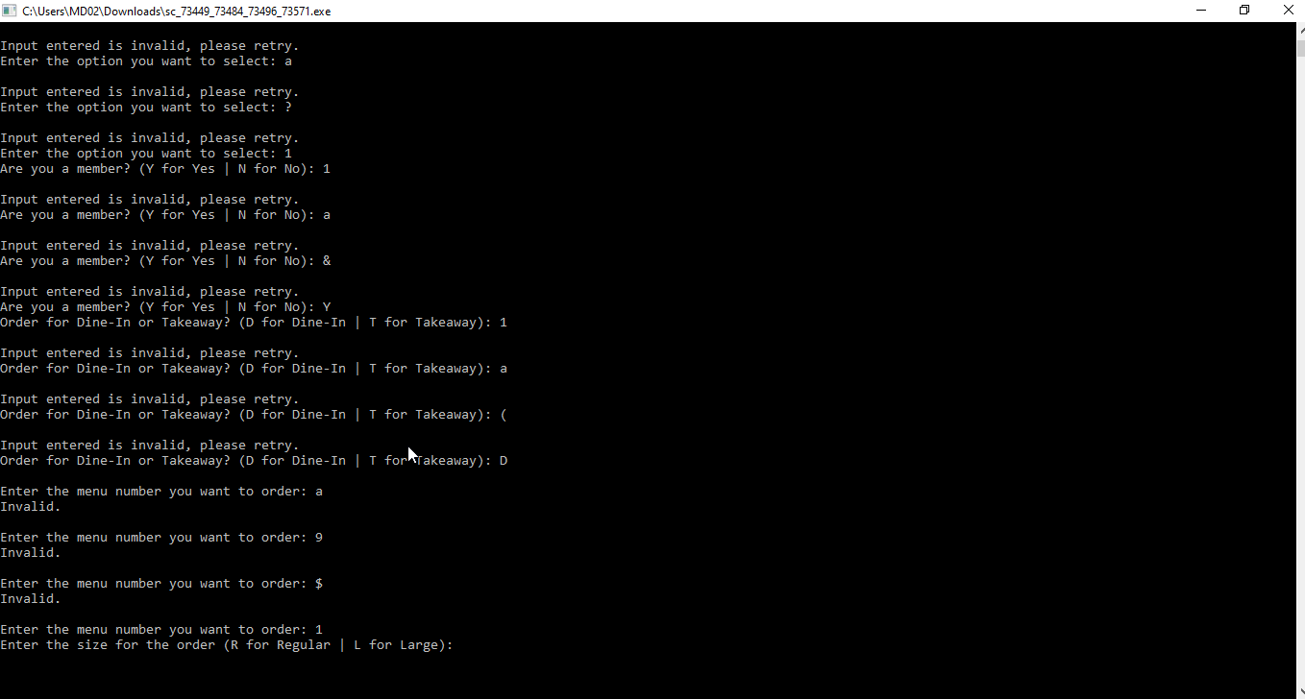
Picture 12
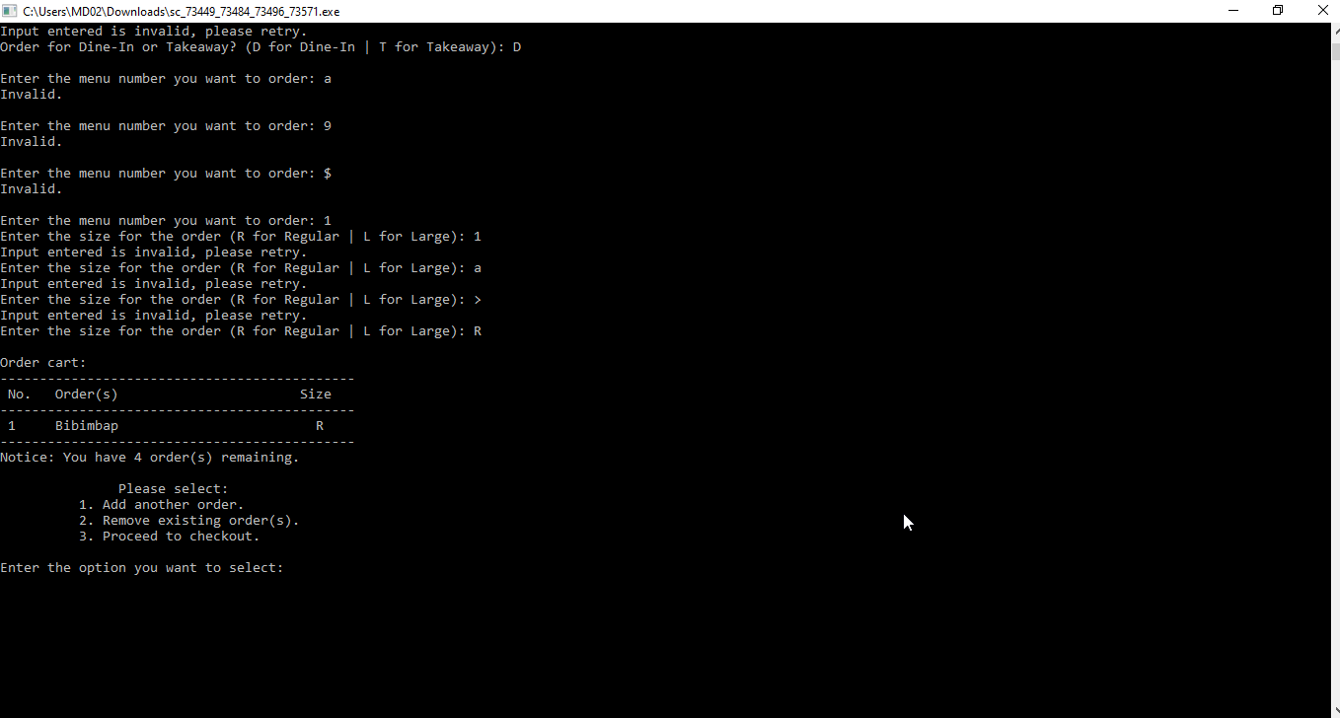
Picture 13
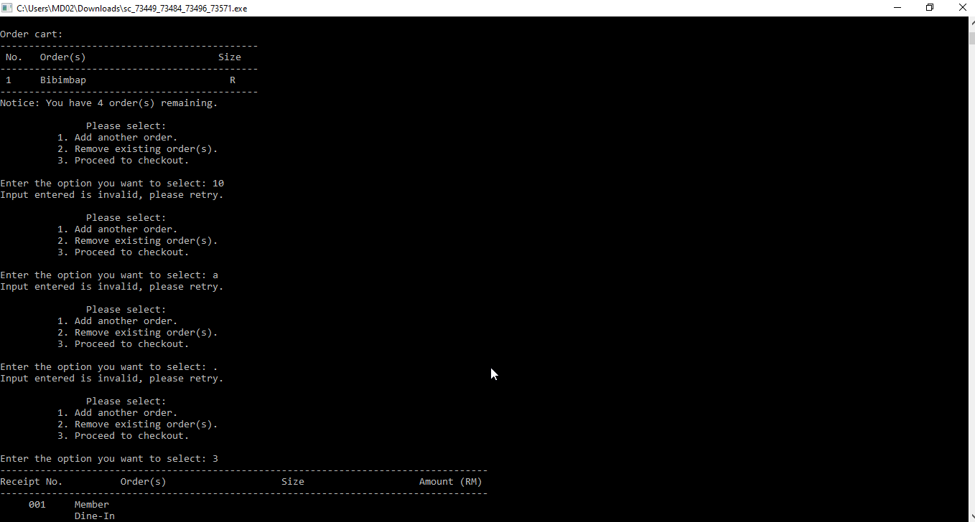
Picture 14

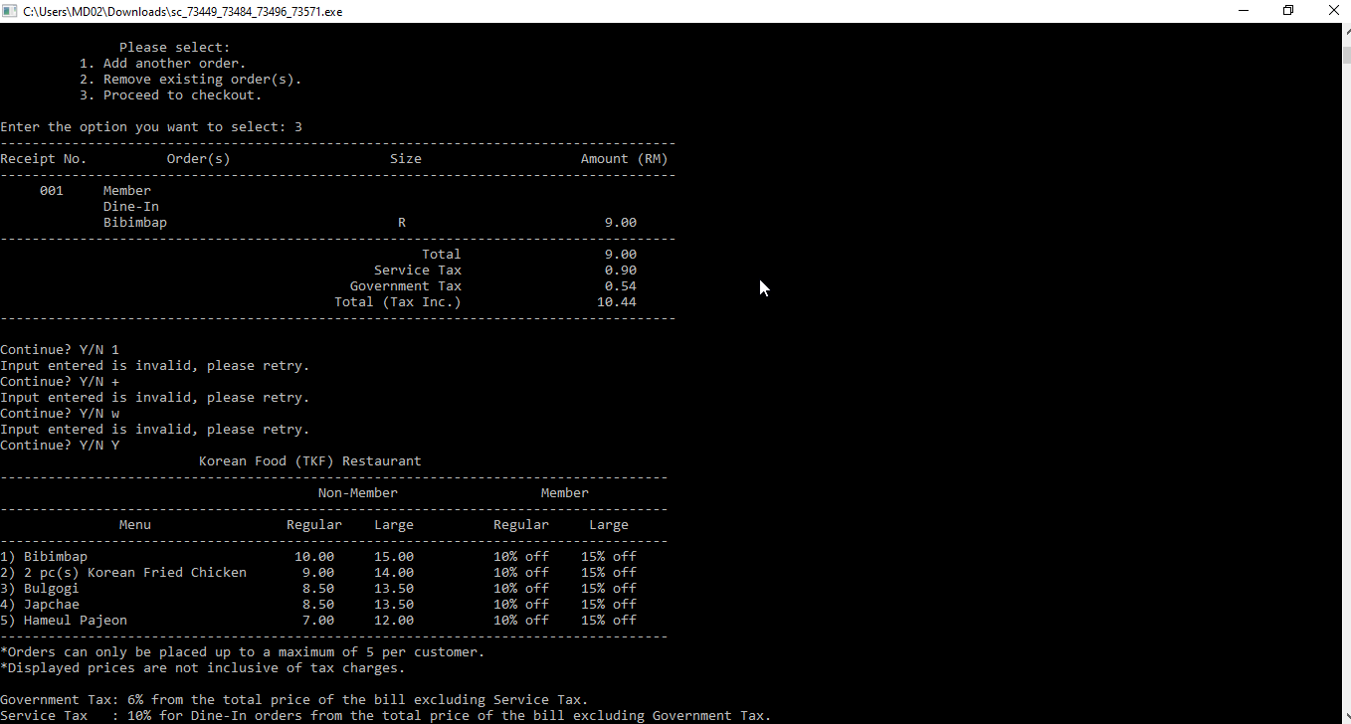
Picture 15

